TOURNAMENT INFORMATION PACKET

IMG National Classic participants & families,

The 7th annual IMG National Classic will be held from March 18th – March 29th at IMG Academy. Top competition from around the country as well as a professional-quality location ensure that this tournament will be unforgettable.

If you have not already made travel plans for the tournament, please do so soon to guarantee your team/guests a room at our brand new IMG Legacy Hotel. Please book by calling the hotel or by clicking the link within an email from the IMG National Classic you should have recently received.

To help us better prepare for your time on campus, please fill out the form linked via the email you should have received from IMG National Classic. We would greatly appreciate you completing this information and returning it no later than March 1, 2019. Required information includes:

- Team Roster (name, position, height, weight and graduation year) – a roster template can be viewed within the email you recently received.
- Marquee Players (please provide us with a list of your top players that we can feature at the event)
- Team High School Logo (jpg or eps format)
- Hotel Accommodations (where are you staying?)
- Arrival/Departure Dates and Times with Airport Information (Tampa or Sarasota/Bradenton)

Included in this packet is a tentative schedule of events for the tournament. If you have any additional questions please don’t hesitate to call myself or Nick Phelps. Additional information can be found on the TOURNAMENT WEBSITE. We look forward to seeing your team compete in Bradenton this year.

Regards,

IMG National Classic Tournament Committee

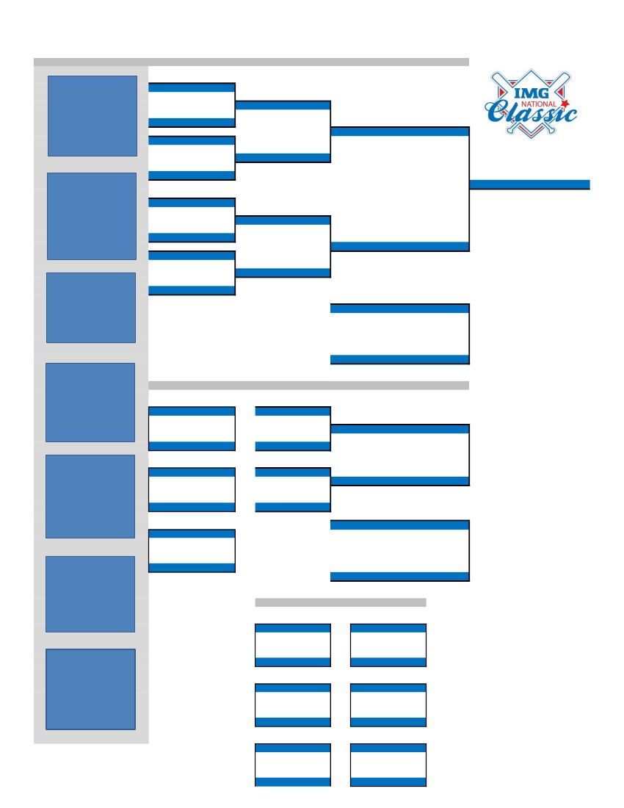

IMG Academy Baseball Complex
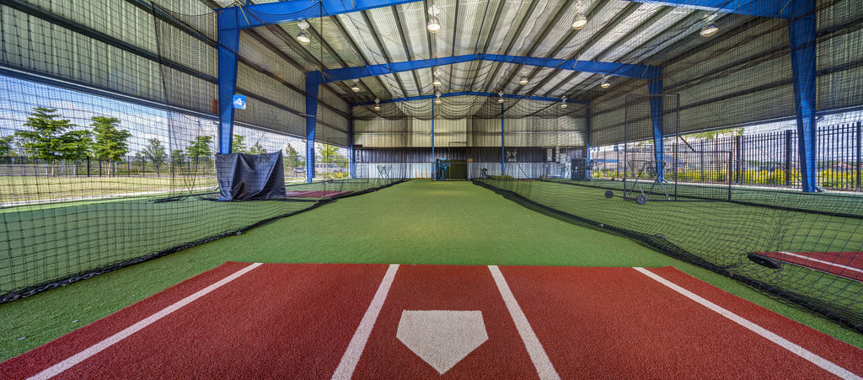
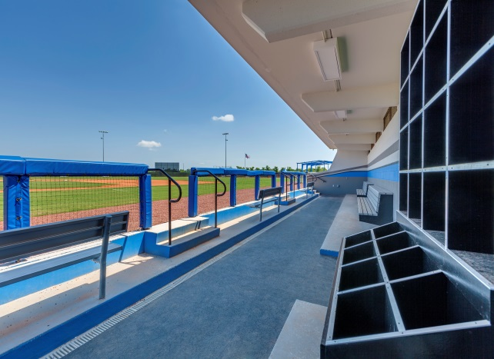
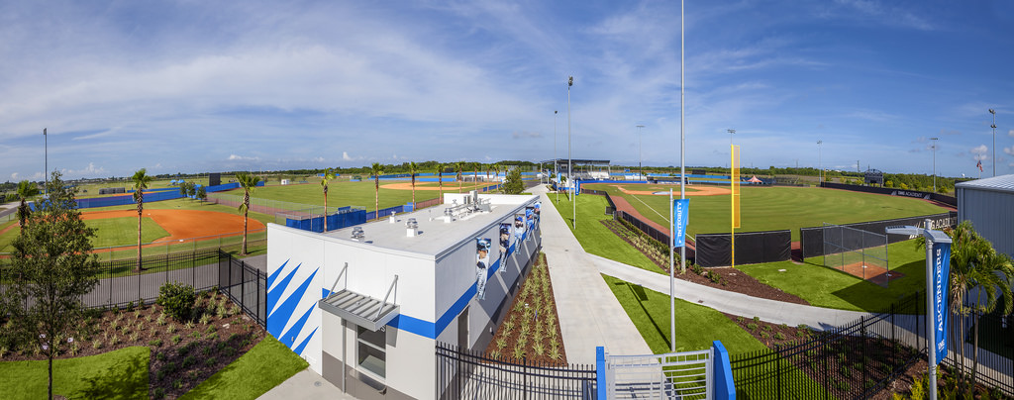

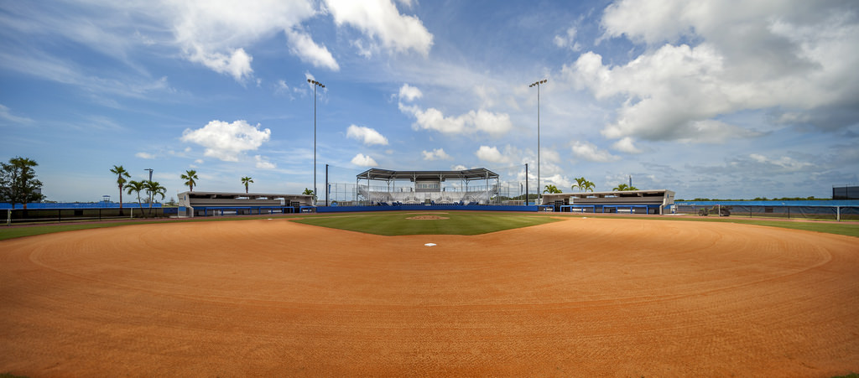

TOURNAMENT INFO & EVENT CONTACTS

DATES: Tournament Week 1 will be held March 18-21, and Tournament Week 2 will take place March 26-29, 2019. There will be a welcome reception/team introductions followed by a coaches meeting on Sunday, March 17th and Monday, March 25th of each tournament week. Games are scheduled to begin on March 18th and March 26th at 10:00 AM.

CONTACTS:

Mitch Andress
Event Coordinator, IMG Performance
Email: Mitchell.Andress@img.com
Office: 941-752-2510
Cell: 615-336-2763

Nick Phelps
Baseball Camp Director, IMG Academy
Email: Nick.Phelps@img.com
Office: 941-739-7480
Cell: 941-567-8558

Colbe Herr
Baseball Program Manager, IMG Academy
Email: Colbe.Herr@img.com
Phone: 941-749-8627

TOURNAMENT RULES

GAME RULES: We will follow Florida High School Athletic Association (FHSAA) rules.

10 RUN RULE: After 5 innings.

DUGOUTS: Please make sure your dugout is clean after your game. Keep players from standing on tarps/portable mounds and from resting their feet on the dugout netting (stadium field). Please hold team meetings outside of dugout after your game.

COURTESY RUNNER: Courtesy runner may be utilized for the pitcher and/or catcher. The same player is not permitted to run for both the pitcher and catcher. Courtesy runner cannot be an active player in the game at time of entry.

3rd TO 1st MOVE: “If F1 steps and fakes to third and clears the rubber, and then fakes or throws to first, he has not violated a rule. If he steps to third and is still in contact with the rubber and in the same motion turns or feints to first, he has balked. If he doesn’t step toward third in his fake, he has balked.”
SP/DH RULE: A starting player can be designated on your lineup card as the SP/DH. Upon exiting the game as the pitcher the player will then become the DH in the same lineup spot.

FIELD PREP: IMG Academy grounds crew will take care of field preparations. Please do not throw or play pepper in front of the dugouts.

GAME BALLS: IMG Academy will provide game balls for the tournament. Game balls will be located in the press box if you run out. The home team will supply game balls to the umpire during the game.

FOUL BALLS: Each team will be responsible for tracking down fouls balls that leave the field of play.

SCORE BOARDS: IMG Academy will provide a person to operate the score board for each game.

RAIN DATE: The tournament committee may elect to play double-headers to avoid extending the tournament in this scenario.

TIE BREAKERS: Head to Head
Runs Allowed
Runs Scored
Coin Flip

BATTING PRACTICE: There will be designated batting practice times in the cages for each team prior to the game.
There will be no on-field batting practice. Each team will have access to ONE CAGE for batting practice in the outdoor cages prior to the game. PLEASE MAKE SURE YOUR PLAYERS HAVE TURF SHOES ON IN THE CAGES. ANY PLAYERS THROWING TO BATTERS MUST WEAR A HELMET.

HOME TEAM: Home team will be decided by a coin flip game prior to each game.

PRE GAME: Home team will take Pre Game first, 50 min before first pitch. Teams will be allotted 10 minutes each. This will allow for 30 minutes of field prep by the grounds crew.

UMPIRES: If a Head Coach is ejected from a game, he is also ejected from the next two (2) games plus a fine. Same applies to assistant coaches. No tolerance policy with assistant coaches speaking to umpires.

SCHEDULE OF EVENTS & TRANSPORTATION

SCHEDULE OF EVENTS | TRANSPORTATION
March 18-21 – Week 1  - March 17: Welcome Reception/Dinner  - March 18: First Round Games  - March 19: Second Round Games  - March 20: Third Round Games  - March 21: Championship/Consolation Games  March 26-29 – Week 2  - March 25: Welcome Reception/Dinner  - March 26: First Round Games  - March 27: Second Round Games  - March 28: Third Round Games  - March 29: Championship/Consolation Games | Tampa International Airport (TPA)  - 55 Minutes from IMG Academy  Sarasota/Bradenton Int’l Airport (SRQ)  - 10-15 Minutes from IMG Academy  Airport Shuttles & Rental Cars  - The campus at IMG Academy is outfitted with transportation service for any of your needs while on campus. Contact transportation@img.com or 941-752-2568.  - Enterprise Rent-A-Car & IMG Academy have teamed up to offer all IMG Academy guests and customers great savings! Customers will receive an additional 5% discount from the lowest retail rate. Click HERE to book and enter discount code “LIMG15.”

DRIVING DIRECTIONS

Directions from Tampa International Airport: Follow I-275 South across the Sunshine Skyway Bridge, to I-75 South. Take I-75 South to Exit 217 (State Road 70), Travel west on State Road 70 (becomes 53rd Avenue) approximately ten miles to 43rd Street West/Bollettieri Blvd. Take a left on Bollettieri Blvd. The entrance to IMG Academy will be straight ahead at the end of Bollettieri Blvd.

Traveling from the North on I-75: Take Exit 217 (old exit 41) and travel west on State Road 70 for approximately ten miles. Go to 43rd Street West/Bollettieri Blvd. Take a left on Bollettieri Blvd. The entrance to IMG Academy will be straight ahead at the end of Bollettieri Blvd.

Traveling from the South on I-75: Take Exit 217 B (old exit 41 B) and travel west on State Road 70 for approximately ten miles. Go to 43rd Street West/Bollettieri Blvd. Take a left on Bollettieri Blvd. The entrance to IMG Academy will be straight ahead at the end of Bollettieri Blvd.

Parking: Parking is located adjacent to the tournament fields in front of the IMG Academy Fieldhouse.

Facility Address: 5650 Bollettieri Blvd., Bradenton, FL 34210

IMPORTANT INFORMATION
Gatorade wants to make sure your team is properly fueled from start to finish. Athletes will have access to Gatorade Prime Energy Chews, Gatorade Thirst Quencher and Gatorade Recover Shakes throughout the IMG National Classic. To learn more about the science behind Gatorade, visit www.gssiweb.org.
GATORADE PRIME: Gatorade Prime Energy Chews are formulated with a blend of carbohydrates and B vitamins to give athletes energy specifically designed for them to be ready and start strong without caffeine. They offer fuel in a convenient and functional form for athletes to take on-the-go.

GATORADE THIRST QUENCHER: Gatorade Thirst Quencher is the most thoroughly researched sports beverage in the world. Scientifically engineered to help athletes perform at their best during athletic activity, Gatorade Thirst Quencher continues to quench thirst, replace fluids and electrolytes, and provide carbohydrate energy to help athletes get the most out of their performance. Help replace what you sweat out with Gatorade Thirst Quencher in Gatorade coolers in the dugouts during all games.

GATORADE RECOVER: Gatorade Recover Protein Shake contains high quality milk-based proteins, including casein and whey that provide essential amino acids to help fuel muscle recovery and help bring muscles back to life. Gatorade Recover Protein Shakes should be consumed as soon as possible after your workout. Fuel your muscle recovery with Gatorade Recover Shakes available at the Gatorade distribution tent at the end of each game.
TRAINERS/MEDICAL: Certified Athletic Trainers will be located at every field each day if there is any need of medical assistance.
SECURITY: The event will be patrolled by IMG Academy Campus Safety personnel. Campus Safety may be reached by calling 941-739-7496 or utilizing emergency call boxes on campus.
TEAM PARKING: Teams can park their cars/vans/buses in the main parking lot next to the IMG Academy Fieldhouse. Teams will be able to access fields and cages from this parking lot.

CONCESSIONS: Select concession items will be available and will be open to all participants and spectators throughout the tournament. Cash and credit cards are accepted. Concessions will be located on the opposite side of the main ticket gate as you enter the complex.

OFFICIAL TOURNAMENT MERCHANDISE: Official Under Armour merchandise will be available on site during the tournament at the merchandise tent located next to the main concessions.

ADMISSION: Admission for spectators will be as follows (coaches and players are free):
- Day Pass: $5
- All-Tournament Pass: $18
- Tournament Program: $5

ALL-TOURNAMENT TEAM: Coaches will be asked to nominate two (2) players at the end of the tournament to be selected to the All-Tournament team. Each player will receive an official Under Armour All-Tournament team T-Shirt.

AREA ATTRACTIONS

BUSCH GARDENS: Located approximately one hour north of the IMG Academy campus lies Busch Gardens, one of the most popular amusements parks in the country. It is one of America’s largest zoological institutions and features over 2,700 animals. The park also consists of a handful of thrilling roller-coasters including the SheiKra, a ferocious, floorless dive coaster that climbs you 200 feet to the edge of a 90-degree drop that inches you mercilessly over the edge. Click HERE to visit their website and to find out more information.

ANNA MARIA ISLAND: Often known as Florida’s best kept secret; Anna Maria Island sits at the southern tip of Tampa Bay and the Gulf of Mexico and is perched north of Longboat Key. There are no high rise buildings in this area, just houses with the “Old Florida” feel, in neighborhoods that are not far from the water’s edge. It is the perfect place to relax, soak up the sun, and enjoy the delights of some award-winning restaurants. The beaches of Anna Maria Island are some of the best on the Gulf Coast. Visit their website by clicking HERE for more information on the beaches, where to eat, and other attractions.

SIESTA KEY BEACH: Siesta Key Beach is central Sarasota's gateway to the sparkling waters of the Gulf of Mexico, an island that combines luxurious amenities with a relaxed vibe that appeals to both visitors and locals. On the east side of this eight-mile long barrier island is Sarasota Bay and Florida's Intracoastal Waterway. It's a scenic trail for boaters interested in exploring the mangrove forests that dot the area, dropping a line for snook or pompano, or cruising to Sarasota's dockside restaurants and pubs. On the island's west side are Siesta Key's glorious white sand beaches, ranked number one in America in 2011 by Dr. Beach, and the calm waters of the Gulf. There’s more to Siesta Key than just beaches and water. The island has a wide variety of entertainment and dining options which can be found in the Siesta Key Village where you will find shops that cater to the island lifestyle. Just remember, sandals are not only allowed, they’re expected. Read more about Siesta Key and all it has to offer by clicking HERE.

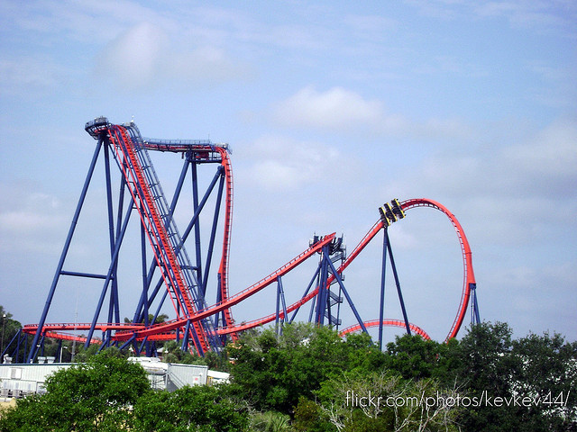
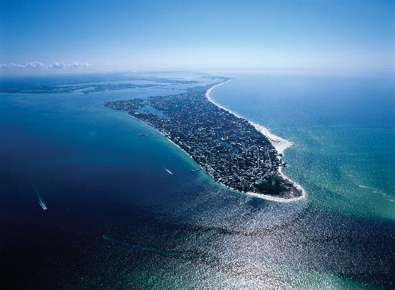
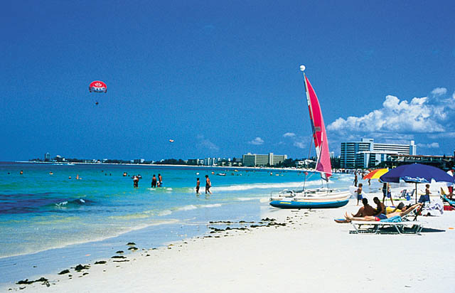

AREA RESTAURANTS
BRADENTON
RESTAURANT | TYPE | ADDRESS | PHONE NUMBER
Anna Maria Oyster Bar | Seafood | 6696 Cortez Road W, Bradenton, FL | 941-792-0077
Fratello’s Chicago Pizzeria | Pizza/Sandwiches/Pasta | 7110 Cortez Road, Bradenton, FL | 941-794-0300
Beef ‘O’ Brady’s | American/Sports | 4925 Cortez Road W, Bradenton, FL | 941-798-6939
Pier 22 Restaurant (On the River) | American/Seafood/Sushi | 1200 1st Avenue West  Bradenton, FL | 941-748-8087
Tijuana Flats | Tex Mex/Burritos/Tacos | 2127 Cortez Road W, Bradenton, FL | 941-756-7351
Jersey Mike’s | Sandwiches/Subs | 4020 14th Street W, Bradenton, FL | 941-748-7827
Sandbar Waterfront Restaurant | Seafood (On Anna Maria Island) | 100 Spring Avenue,  Anna Maria, FL | 941-778-0444
Olive Garden | Italian | 4420 14h Street W.  Bradenton, FL | 941-756-2370
Chipotle | Mexican/Burritos/Tacos | 1608 Cortez Road W.  Bradenton, FL | 941-752-0425
SARASOTA
RESTAURANT | TYPE | ADDRESS | PHONE NUMBER
Marina Jack’s | American/Seafood | 2 Marina Plaza,  Sarasota, FL | 941-365-4232
Owen’s Fish Camp | American/Seafood | 516 Burns Court, Sarasota, FL | 941-951-6936
Siesta Key Oyster Bar | American/Seafood | 5238 Ocean Blvd., Sarasota, FL | 941-346-5443
The Broken Egg | Breakfast/Lunch | 6115 Exchange Way, Lakewood Ranch, FL | 941-388-6898
Buffalo Wild Wings | American/Sports | 5235 University Pkwy, Sarasota, FL | 941-351-8584
Jason’s Deli | Deli/Sandwich/Salad | 5231 University Pkwy, Sarasota, FL | 941-351-5999
The Old Salty Dog (On The Bay) | American/Seafood | 1601 Ken Thompson Pkwy., Sarasota, FL | 941-388-4311
Duffy’s Sports Grill | American/Sports | 3005 University Pkwy., Sarasota, FL | 941-777-2110
Columbia Restaurant | Spanish/Cuban | 411 St. Armands Circle, Sarasota, FL | 941-388-3987

SPRING TRAINING GAMES

PIRATES SPRING TRAINING GAMES: Since 1969, the Pittsburgh Pirates have called Bradenton, FL their Spring Training home. In 2013, LECOM Park underwent major renovations, including a 19,000 square foot boardwalk spanning the outfield, making it one of baseball’s finest spring training facilities. Click HERE to view the 2019 Pirates Spring Training schedule. Contact Nolan Bialak at nolan.bialak@pirates.com or (941) 747-3031 ext. 4350 for more information.

LECOM Park Address:
1611 9th Street W
Bradenton, FL 34205
From North (St. Petersburg):
Go over Skyway Bridge to Exit 5 (US19 South).
Continue on 41 South (Bradenton/Sarasota).
Make a right turn onto 17th Avenue West and continue to LECOM Park.
From South (Sarasota):
Take Route 41 North to Cortez Road, go straight onto Business 41 and turn right onto 17th Ave. West.
Ballpark is located at intersection of 17th Avenue West and 9th Street West.
From Interstate 75:
Exit I-75 at S.R. 64 West (exit 220 if traveling south, exit 220B if traveling north).
Go west on Route 64 to 9th Street West and turn left to the ballpark.

ORIOLES SPRING TRAINING GAMES: 2019 marks the tenth consecutive Spring Training for the Baltimore Orioles at Ed Smith Stadium in Sarasota, FL. Click HERE to view the 2019 Orioles Spring Training schedule.

Ed Smith Stadium Address:
2700 12th Street
Sarasota, FL 34237

Driving Directions from the North: Driving Directions from the South:
- Take I-75 to exit 213 (University Parkway) 1. Take I-75 to Exit 210 (Fruitville Road)
- Head west on University to Tuttle Avenue 2. Head West on Fruitville to Tuttle Avenue
- Turn left onto Tuttle Avenue and head south 3. Turn right on Tuttle to 12th Street
- Stadium is on the right at the intersection of 12th Street 4. Ed Smith Stadium is on the left
and Tuttle Ave.

SPONSORS

IMG National Classic would like to thank the following sponsors & partners:

